23.04.2018



**MIDDLE EAST TECHNICAL UNIVERSITY**

DEPARTMENT OF ELECTRICAL AND ELECTRONICS ENGINEERING

**EE 564** Project #2

***MOTOR WINDING DESIGN & ANALYSIS***

GÖKHAN ÇAKAL – **2332120**

Contents

1. Introduction 2

2. Winding Design 3

2.1. Lamination Selection 3

2.2. Winding Configuration 3

2.3. Winding Factors 4

2.4. Number of Turns & Conductors Calculation 5

2.5. Fill Factor & Wire Size 6

2.6. Voltage & Current Ratings, Output Power 7

2.7. MMF Waveforms 8

3. Motor Parameter Estimation 9

3.1. Magnetic and Electric Loading 9

3.2. Torque & Speed Calculation 10

3.3. Equivalent Circuit Parameters 11

3.4. Approximate Core and Copper Losses 12

4. Detailed Analysis & Verification 13

4.1. Performance Curves 13

4.2. Performance Data 15

4.3. Current and Voltage Waveforms 17

4.4. Flux Density Distribution 19

4.5. Effect of Skewing 21

4.6. Comparison of Analytical and RMxpt Results 22

5. Conclusion 23

6. References 23

# Introduction

In this report, an induction motor will be designed with selected lamination available in the market. Induction motors are work horse of the industry of today. They have wide range of usage. In this study, we will first select a lamination and then decide motor parameters such as number of poles, number of turns and phase currents etc. Rated power, speed and torque also will be determined analytically. Design procedure will be listed clearly and important design parameters such as electric and magnetic loading will be studied. Analytical results will be compared with simulations results, which will be obtained using Maxwell RMxprt tool.

At the end of the study, an induction motor will be achieved with 4 kW power rating and 26 Nm rated torque with 90 % efficiency.

# Winding Design

## Lamination Selection

In the design lamination 3 is used [[1]](https://github.com/odtu/ee564-2018/blob/master/Project2/ks(3).pdf), general properties of which is listed in Table 1.

Table 1: Properties of lamination 3

|  |  |
| --- | --- |
| Property | Value |
| Stator slot number | 36 |
| Rotor slot number | 34 |
| Stator outer diameter | 200 mm |
| Stator inner diameter | 135 |
| Rotor outer diameter | 134.6 |
| Rotor inner diameter | 61 mm |
| Air gap clearance | 0.3 mm |
| Stator slot area | 114 mm2 |

Air gap clearance of 0.3 mm is chosen in the design. This effects reluctance and magnetizing inductance of the induction motor. In rotor side, we have shorted aluminum bars. In the stator, three phase windings are placed with correct order.

## Winding Configuration

In the design, I decided to use **single layer, integral slot** winding diagram. Therefore, number of slots per pole phase can be calculated as follows. **Number of poles** are chosen as 4.

With this configuration, we have following winding connection over one pole pairs.

|  |  |  |  |  |  |  |  |  |  |  |  |  |  |  |  |  |  |
| --- | --- | --- | --- | --- | --- | --- | --- | --- | --- | --- | --- | --- | --- | --- | --- | --- | --- |
| A1 | A2 | A3 | -C1 | -C2 | -C3 | B1 | B2 | B3 | -A1 | -A2 | -A3 | C1 | C2 | C3 | -B1 | -B2 | -B3 |

Here, 18 stator slots are shown for one pole pair. Rest of the windings repeat this cycle for each pole pair. Also, 3D winding diagram of the designed motor is shown in Figure 1.

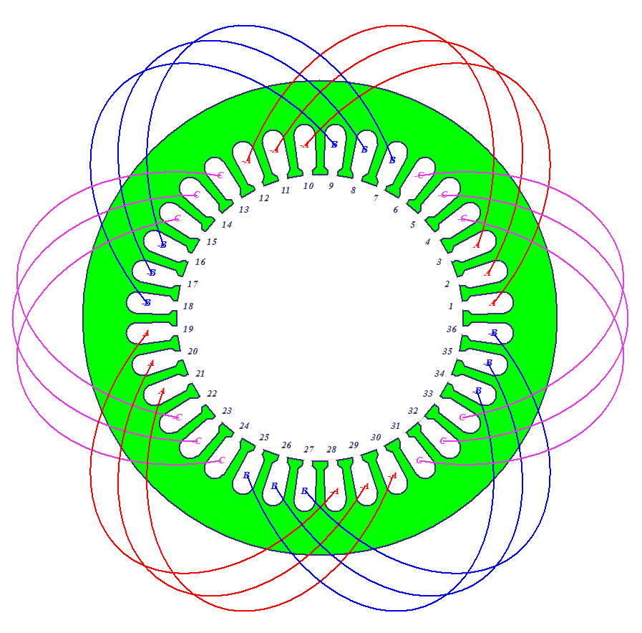

Figure 1: Winding diagram for single layer integral slot winding

## Winding Factors

Here, we have distributed winding diagram with full pithed coils. Pitch factor is unity due to full pitched coils. Distribution factor is calculated as follows.

Where h represents harmonics and coil span is 180 degrees due to full pitched coils.

Where h is harmonics, q is number of slots per pole per phase, which is 3 as calculated before, and α is the slot angle in electrical degrees. It is calculated as follows.

Using pitch factor and distribution factor, winding factor is calculated as follows. Also, winding factor for some harmonics are listed in following table.

Table 2: Winding factor for some harmonics

|  |  |  |  |
| --- | --- | --- | --- |
|  | kp | kd | kw |
| Fundamental | 1 | 0.9598 | 0.9598 |
| 3rd | -1 | 0.6667 | -0.6667 |
| 5th | 1 | 0.2176 | 0.2176 |
| 7th | -1 | -0.1774 | 1.774 |

Note that even harmonics does not exist because they have zero pitch factor.

## Number of Turns & Conductors Calculation

In order to calculate number of turns per phase, we can use induced voltage relation. To do this, we first determine some machine parameters. First of all, let’s assume machine is **wye connected** and supplied from **380 Vll-rms** voltage source. In that case, we have 220 Vrms phase voltage.

Where erms is the induced phase voltage, which is 220 V, Nph is the number of turns per phase, f is the supply frequency, kw is the fundamental winding factor, which is 0.9588, and is the peak flux per pole. Flux per pole is calculated as average flux density in the air gap and pole area. Average flux density is also known as **magnetic loading** of the machine, which is usually taken as 0.35-0.6 T. In the design, let’s assume **supply frequency is 50 Hz.**

where diagap is air gap diameter and length is the axial length of the motor. **Let’s define axial length of the motor is equal to inner stator diameter of the motor, which is 135 mm.**

Using this, number of turns per phase can be calculated easily.

Number of conductors in a stator slot is calculated as follows.

## Fill Factor & Wire Size

Here, let’s define **fill factor of the machine is 0.7**. This determines ratio of total wire cross section area to total slot area in a slot. Using this, we can calculate cross section area of a wire.

In this part, we should also consider current density in the account. At the end of the design, current density should be checked whether we are safe or not.

Current density up to 5 A/mm2 is safe.

## Voltage & Current Ratings, Output Power

In the design, we have 380 Vrms line voltage and wye connection. This means 220 Vrms phase voltage. For current calculation, we should first determine electrical loading of the machine. Electrical loading is rms ampere turns per unit length of the air gap and its unit is A/m. It is calculated as follows.

In this equation, only unknown is phase current and we should also set electrical loading. In the induction machines, it is safe to have 20-65 kA/m of electrical loading. In our design, let’s set **electrical loading as 24 kA/m.** Then, phase current can be calculated easily.

To be safe, let’s check current density of windings.

Which is safe to go.

Using these findings, we can calculate power ratings of the machine. To do this, we should first make power factor and efficiency assumptions. Let’s assume power factor of machine is **0.82 and efficiency is 0.9.** At rated operation, these assumptions hold and real values are very close. Using them, let’s calculate input and output power.

## MMF Waveforms

In this part, MMF waveforms for given winding configuration will be provided. In the design, we have 34 conductors for each slot. Three different instants for a balanced three phase current will be provided.





Figure 2: Sample MMF waveform





Figure 3: Sample MMF waveform





Figure 4: Sample MMF waveform

# Motor Parameter Estimation

In the design, **axial length of the motor** is chosen the same as stator inner diameter, which is **135 mm.** Additionally, **air gap clearance** is chosen as **0.35 mm**.

## Magnetic and Electric Loading

In previous parts, we determined these values in order to find current and number of turns parameters. In order to remind them, **magnetic loading is chosen as 0.35 T**, which is air gap average flux density. 0.35-0.6 T is safe to choose values for magnetic loading. In order to find stator teeth and yoke flux density, we can get help from RMxprt tool of Maxwell. In the Maxwell, dimensions of the design are provided and design is analyzed. Following results are obtained for magnetic data.

Table 3: Magnetic parameters of the design obtained from RMxprt

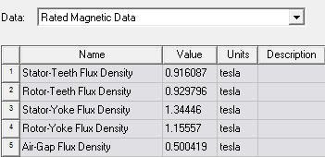

As can be seen, air gap flux density is 0.5 T. In our analytical model, we take magnetic loading as 0.35 T, which is average flux density in the air gap. Above values are peak values and our analytical calculation has peak value of 0.35*pi/2 = 0.55 T, which is quite close the simulation results above. As can be seen, stator yoke has peak flux density of 1.34 T. Our material saturates at 1.6-1.7 T and this much magnetic loading is safe for our design.

In order to find current rating, we set electrical loading in previous part. In order to remind, electrical loading is rms ampere turns per unit length of the air gap. It is calculated as follows.

In the induction machines, it is safe to have 20-65 kA/m of electrical loading. In our design, we have **electrical loading of 24 kA/m,** which is acceptable.

## Torque & Speed Calculation

We can find speed using synchronous speed and assume some slip. In the design, we have synchronous speed of following value;

Induction machines work close to synchronous speed at rated operation. Therefore, it is reasonable to assume small slip, such as **s=0.03**. Therefore, actual speed can be calculated as follows.

Assuming power factor and efficiency values 0.82 and 0.9 respectively, we calculated output power as 4 kW in previous part. Using these values, rated torque can be calculated easily.

## Equivalent Circuit Parameters

* Stator phase resistance

In order to determine this, let’s focus on one turns total length. We have axial length of 0.135 m for each conductor in a slot. Considering slot diameter of the design, end windings are calculated as 0.12 m for each turn. Therefore, one turn length of the design is calculated as follows.

Where, Nph is the number of turns per phase and lphase is the total length of the copper conductors in a phase. Therefore, phase resistance can be calculated as follows.

Note that here resistivity is calculated for 75 °C, which is operating temperature.

* Magnetizing inductance

Magnetizing inductance of the machine can be calculated using equivalent magnetic circuit of the induction motor. However, since it is not covered yet, we should find another way. After some research in the literature, following formula is obtained to define magnetizing inductance.

Magnetizing inductance depends on square of the number of turns as expected. As we have larger magnetizing inductance, we have larger power factor and thus better machine. Also note that as air gap clearance decreases, reluctance of the motor decreases and inductance increases.

* Leakage inductance

Stator and rotor leakage inductance can be thought as 2-5% of magnetizing inductance, as a rough estimation. Let’s take rotor and stator leakage inductance is 3% of the magnetizing inductance. Therefore, following result is achieved.

## Approximate Core and Copper Losses

Copper losses are calculated as follows.

Core losses are calculated on stator. At rated operation, since rotor induced voltage & current frequencies are very small, core losses on rotor are can be ignored. We can calculate core losses on stator core as follows.

Where Bm is the peak flux density in the stator, which is 1.35 T, kh, kc and ke are coefficients for hysteresis loss, eddy-current loss and excess core loss respectively. These are defined for each material. In our core material they are 173.3 0.086 2.068, respectively. In the equation, f is the frequency of induced voltage and currents in the armature, which is 50 Hz. In the above equation, core loss is defined per volume.

# Detailed Analysis & Verification

## Performance Curves

Using RMxprt tool of the Maxwell finite element analysis software, three phase induction motor is modeled with above sizes. Analytical results are compared with RMxprt results. After analyzing model in Maxwell, following results are obtained.

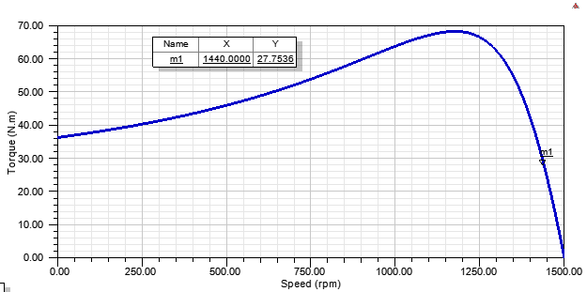

Figure 5: Torque speed characteristics

According to analysis results, it is observed that rated speed of the motor is 1443 rpm, with slip of 0.04. Operation point is shown with a marker in the figures.

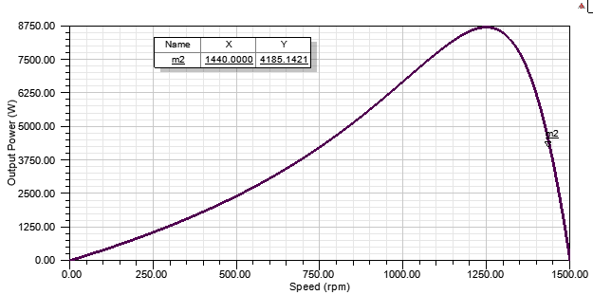

Figure 6: Output power vs speed characteristics

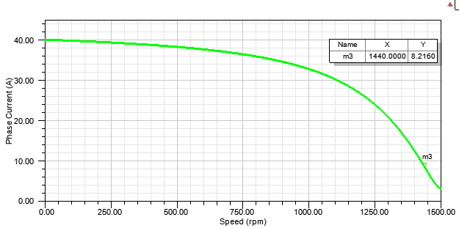

Figure 7: Phase current vs speed characteristics

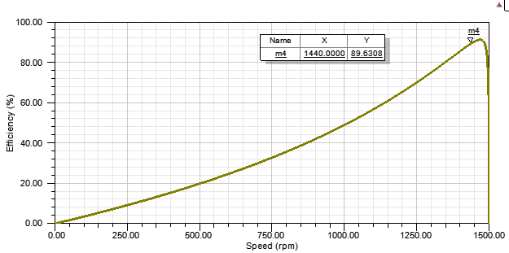

Figure 8: Efficiency vs speed characteristics

## Performance Data

Table 4: Magnetic data obtained from RMxprt

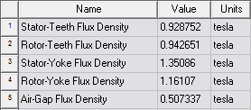

As can be seen air gap flux density is 0.51 T. But this is peak value, not average. Average value corresponds to 0.33 T, which is very close to 0.35 T, analytical magnetic loading. Also, note that peak flux density in the stator yoke is 1.35 T. At this level, the core is not saturated.

Table 5: Electrical data obtained from RMxprt

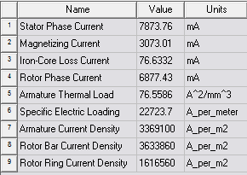

Here, we observe that electrical loading is 23 kA/m, which is close to 24 kA/m, analytical electrical loading. Also, phase current is 7.9 A. Note that current densities are in safe region.

Table 6: Rated performance of the design obtained from RMxprt

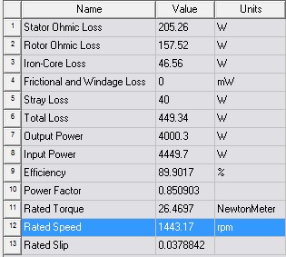

Here, note that friction and windage losses are neglected. We have rotor ohmic losses due to rotor currents in aluminium shorted bars. This is not taken into account in analytical calculations. Core losses are calculated with enough accuracy.

Table 7: Material consumption of the design obtained from RMxprt

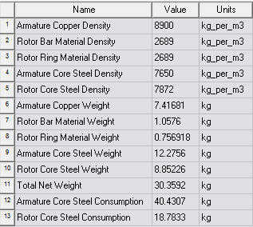

According to results, total motor weight will be 30 kg.

Table 8: Rated parameters of the design obtained from RMxprt

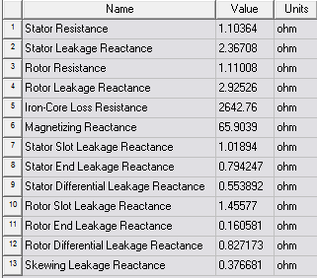

According to results, magnetizing reactance and leakage reactance calculations are not accurate. This calculations are to be further improved. Resistance calculations are acceptable.

All analtyical and RMxprt results are listed and compared in Table 9.

## Current and Voltage Waveforms

2D design of the induction motor is created using RMxprt tool and current and voltage waveforms are achieved at steady-state operation.

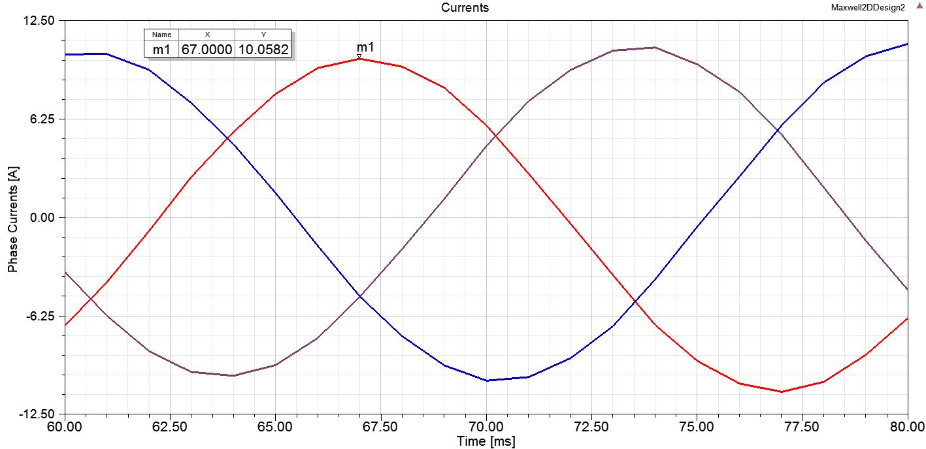

Figure 9: Phase currents

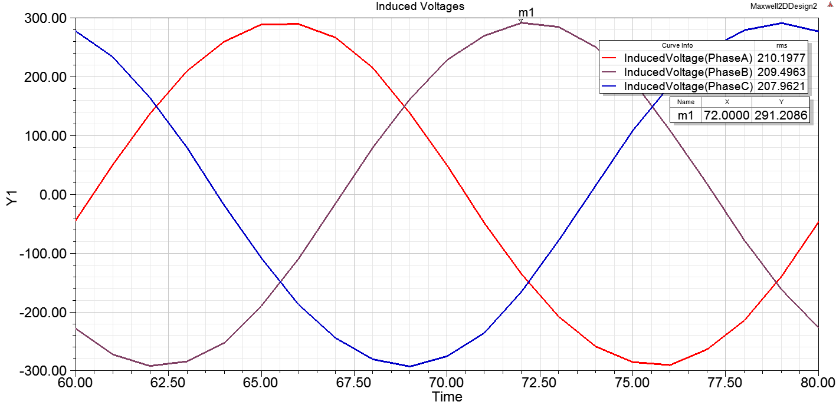

Figure 10: Induced voltages

Here, analytically we assumed that induced voltage is equal to phase voltage, which is 220 Vrms. However, it is observed that induced voltage is around 210 Vrms. This is due to voltage drop on stator resistance and leakage reactance. Since these impedance is small, at rated operation, we neglected voltage drop on them and proceed.

In the Figure 9, we see that phase current has rms of 7.1 A. This is less than analytical calculation, which is 8.2 A. Also, in the RMxprt, phase current is listed as 7.9 A. I did not understand why RMxprt and 2D analytical results show different current values.

## Flux Density Distribution

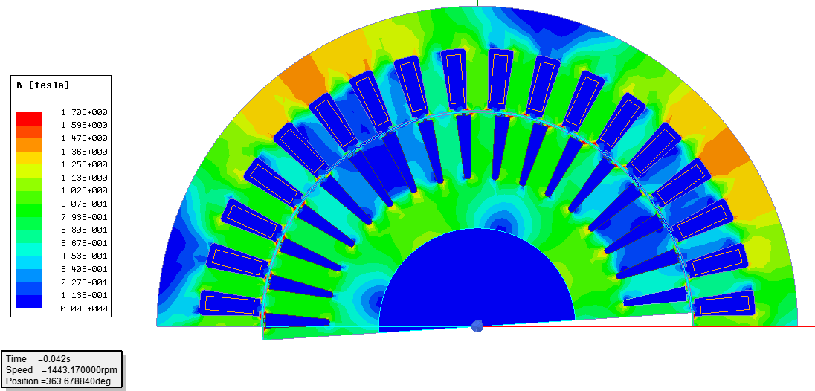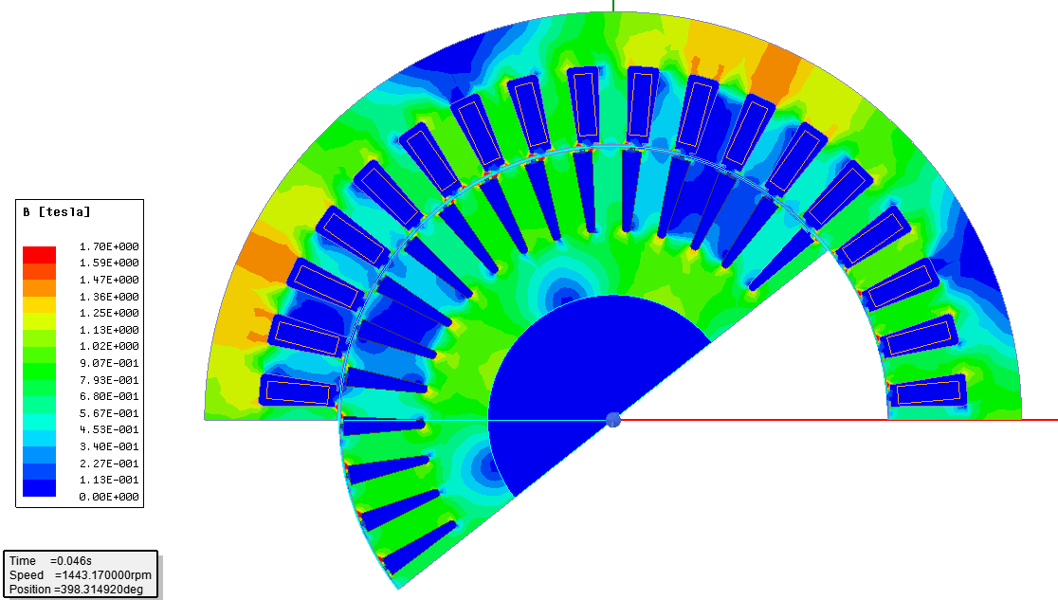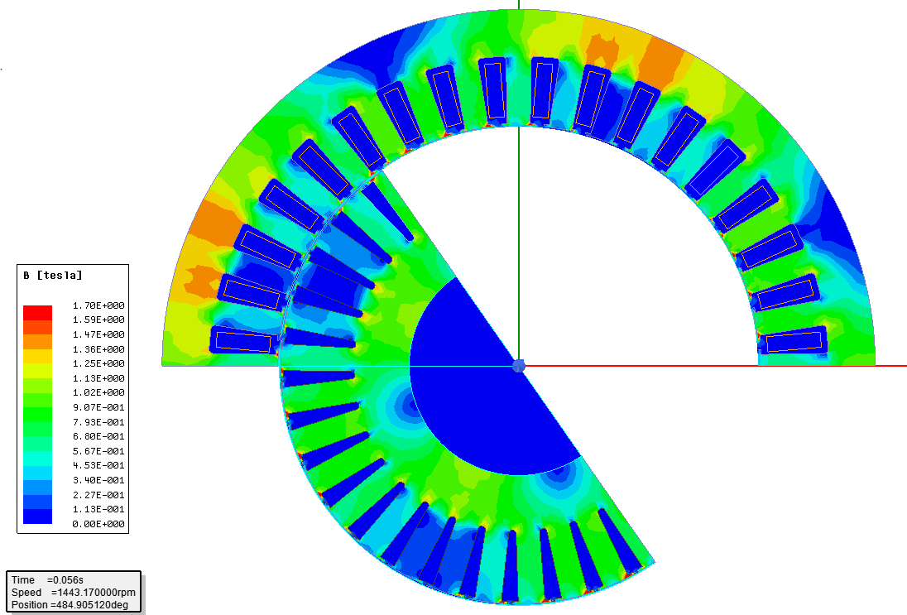

Figure 11: Flux density distribution for different instances

As can be seen in the flux distribution, flux density reaches 1.3-1.4 T at the stator yoke. Since we have half symmetry in the system, solution is done using half symmetry in order to avoid computational load. We have four pole system, which can be understood by looking at the back core flux density distribution.

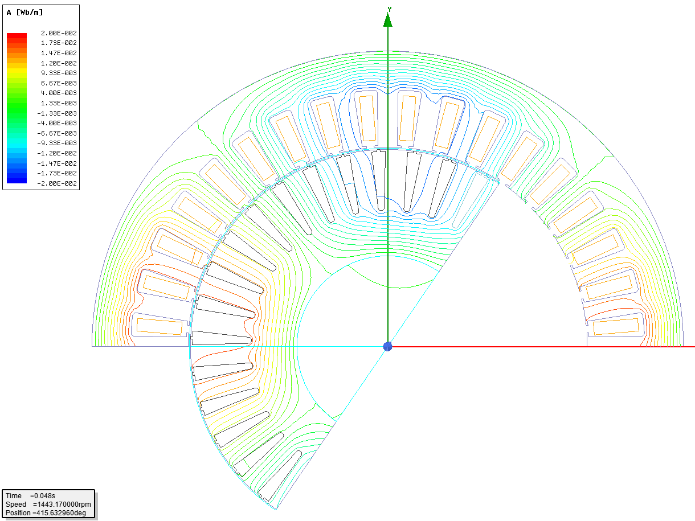 Figure 12: Flux lines

Here, we can see more clearly how flux lines follow a path in the stator.

## Effect of Skewing

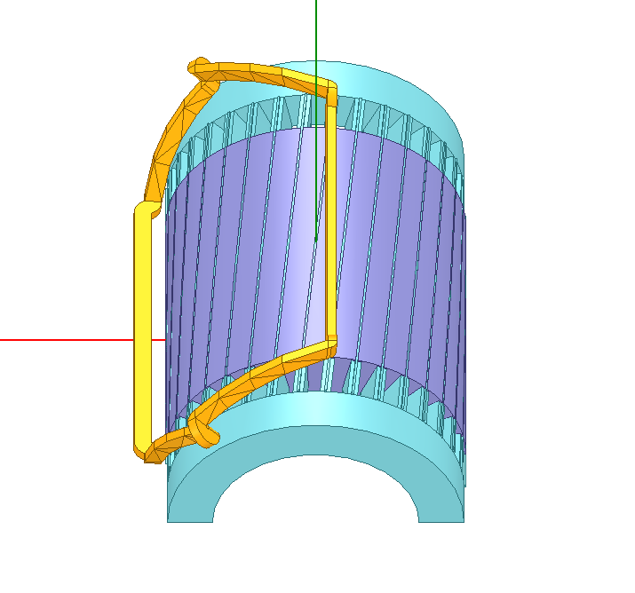

Figure 13: Effect of skewing

In the figure, a stator turn, rotor core and rotor aluminum bars are shown. Here, we have half symmetry also. Note that rotor configuration have skewing of 1 rotor slot. This enables to have less cogging torque in the design. Especially at low speeds or at start-up, cogging torque becomes problem. It results from interaction of stator MMF and rotor core. This effect is eliminated with skewing.

## Comparison of Analytical and RMxpt Results

Table 9: Comparison of analytical and RMxprt results

|  |  |  |
| --- | --- | --- |
|  | Analytical | RMxprt |
| Rated power | 4 kW | 4 kW |
| Rated speed | 1450 rpm | 1443 rpm |
| Rated slip | 0.03 | 0.038 |
| Rated torque | 26.3 Nm | 26.5 Nm |
| Phase current | 8.2 Arms | 7.9 Arms |
| Efficiency | 90 % | 90 % |
| Air gap flux density (Magnetic loading) | 0.35 T | 0.33 T |
| Electrical loading | 24 kA/m | 22.7 kA/m |
| Stator copper loss | 188 W | 205 W |
| Core loss | 41 W | 46 W |
| Power factor | 0.82 | 0.85 |
| Stator resistance | 0.93 Ω | 1.1 Ω |
| Stator leakage reactance | 5.6 Ω | 2.37 Ω |
| Magnetizing reactance | 191 Ω | 66 Ω |

In the results, main parameters such as magnetic loading, electrical loading, torque and speed have consistency between analytical and simulation results. We don’t have accurate inductance calculation. Leakage reactance and magnetizing reactance calculations are not accurate and to be improved.

# Conclusion

In this report, an induction motor is designed with 4 kW power rating. First of all, a lamination is selected from a manufacturer. With this lamination, number of stator slots are determined. After that, pole number is set at 4. Pole number effects stator yoke density and winding configuration. With three phase induction motor, integral slot, single layer winding diagram is studied. With 36 stator slots and 4 pole, number of slots per pole per phase is achieved as 3. After that, winding factors for a few harmonics are determined. Since we have full pitched winding, we have 1 for pitch factor and since we have distributed winding diagram, we have distribution factor close to 1. A critical step is followed in the design process, which is number of turns. With induced voltage relationship, required number of turns per phase is achieved by assuming 380 V wye connection. Electrical and magnetic loading parameters are determined by required attention with safe limits. At the end, 4 kW, 26 Nm induction motor is achieved with 90 % efficiency.

Analytical results are confirmed with RMxprt tool of Ansys Maxwell software. Analytical results showed consistency with simulation results except magnetizing and leakage inductance calculations. In order to have more accurate results for them, further analysis is required for magnetic circuit equivalent of the induction motor.

In overall, this study was teaching and we learnt how to design an induction motor and its winding configuration.

# References

[1] https://github.com/odtu/ee564-2018/blob/master/Project2/ks(3).pdf